Site Purpose

To provide a website that publishes the local weather for Franklin, MU and some of the surrounding cities. It will also include an informational page that contains information for storms in the area and will also include emergency contact information. The site will also have a page dedicated to pictures of the surrounding cities, mainly focusing on the different weather patterns in the environment.

Target Audience

For residents living in Franklin and surrounding areas, and provide information for someone who might be looking to travel to this area. It will also have a page label Storm Center that will present information on any severe storms coming and also emergency preparedness.

Site Map

The header for the home page is going to have the logo on the left hand corner with the website name in the middle.

The navigational bar is going to have a link to the home page and a link of the cities (Franklin, Greenville and Springfield), a link to the Storm Center page and the Gallery.

The body will contain the local weather or current information of local happenings. It will also display titles of information of a high overview of the 3 different cities with the current temperature in that location and also provide a nature picture of that location.

The footer is going to contain the contact information of the owner of the website. It will also provide the copy write information with the location of the city and state.

Color Scheme

The colors I want to choose will be the natural colors and the soft and neutral browns and greens with a variation of the tones and to better blend with the pictures of the nature shots that will be shown in the tiles of the homepage.

Typography

The font I choose is going to be Courier New. I like this font because it provides a little extra spacing between the letters and I believe this will help provide easier reading on the different screen views. To me this font has a nice simple sentimental look to it to nicely tie it to the natural colors of the website and to also give the towns a nice rural feel to them.

This is a sample text written in Courier New font.

Wire-Frame Sketches

SMALL VIEW SKETCH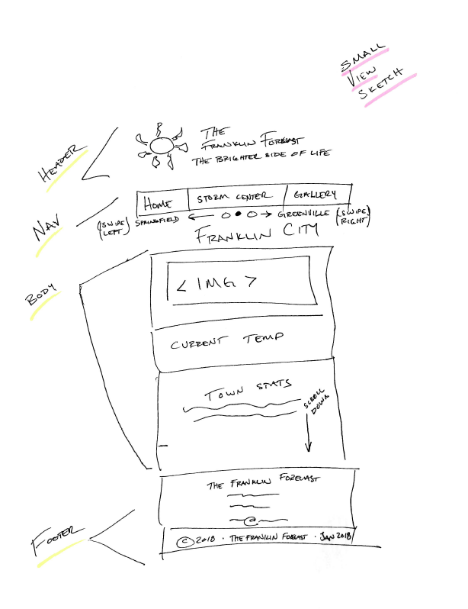

MEDIUEM VIEW SKETCH

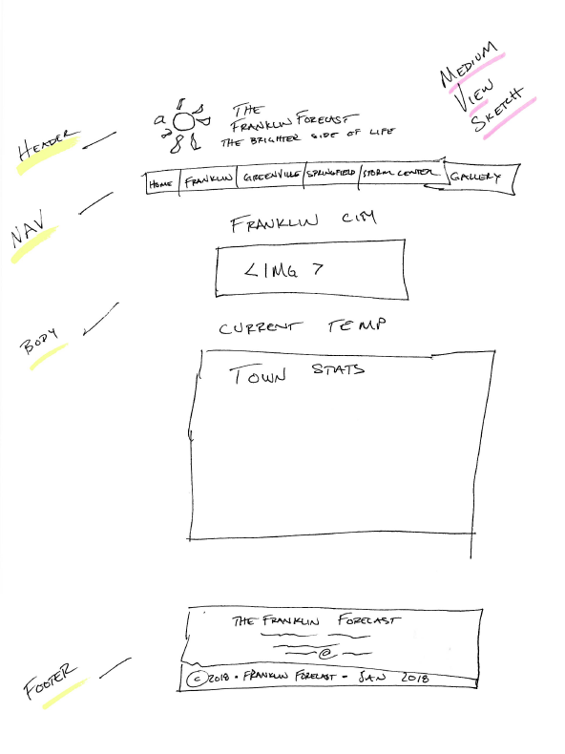

LARGE VIEW SKETCH

